

**Assignment Of**

**ITEC-515 DB Administration & Management**

**Practice Lab Task 4**

**Submitted To:**

**Sir.Kamran Dahiri**

**Professor Dept:**

**Information Technology**

**Submitted By:**

**Mubashir Ali S/O**

**Mansoor Ali**

**(2k20/ITE/73) Group(A)**

**Lab Practice 4 – Database Systems**

**Practice Question 1**

Create the **DEPT** table based on the following table instance chart.

**See output below**

DEPT

|  |  |
| --- | --- |
| ID | Name |
| Length (7) Number | Length(25) varchar |

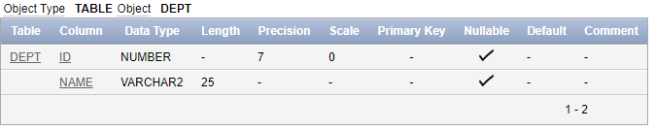

**Answer:**

Create table DEPT(ID number(7),Name Varchar(25));

Describe DEPT;

**Practice Question 2**

Create the **EMP** table based on the following table instance chart.

**See output below**

|  |  |  |  |
| --- | --- | --- | --- |
| ID | Last_Name | First_Name | DEPT_ID |
| Length (7) Number | Length(25) varchar | Length(25) varchar | Length(7) number |

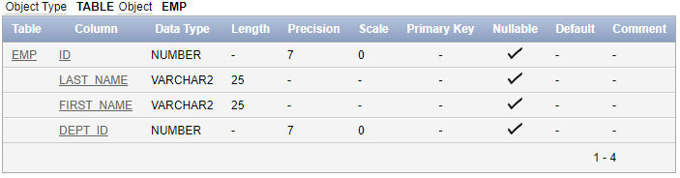

**Answer:**

Create table EMP(ID number(7),Last_Name Varchar(25),First_Name Varchar(25),Dept_ID Varchar(7));

Describe EMP;

**Practice Question 3**

Insert data into DEPT Table. Data is shown in following output

**See output below**

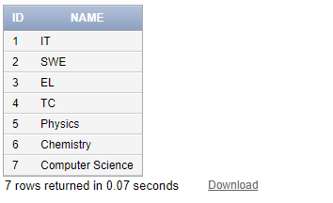

**Answer:**

1. Insert into DEPT(ID,NAME)

VALUES(1,'IT');

2. Insert into DEPT(ID,NAME)

VALUES(2,'SWE');

3. Insert into DEPT(ID,NAME)

VALUES(3,'EL');

4. Insert into DEPT(ID,NAME)

VALUES(4,'TC');

5. Insert into DEPT(ID,NAME)

VALUES(5,'Physics');

6.Insert into DEPT(ID,NAME)

VALUES(6,'Chemistry');

7.Insert into DEPT(ID,NAME)

VALUES(7,'Computer Science');

Select *

From DEPT;

**Practice Question 4**

Insert data into EMP Table. Data is shown in following output

**See output below**

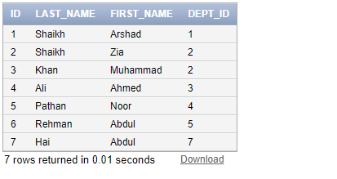

**Answer:**

1. Insert into EMP(ID,LAST_NAME,FIRST_NAME,DEPT_ID)

VALUES(1,'Shaikh','Arshad',1);

2.Insert into EMP(ID,LAST_NAME,FIRST_NAME,DEPT_ID)

VALUES(1,'Shaikh','Zia',2);

3. Insert into EMP(ID,LAST_NAME,FIRST_NAME,DEPT_ID)

VALUES(1,'Khan','Muhammad',3);

4. Insert into EMP(ID,LAST_NAME,FIRST_NAME,DEPT_ID)

VALUES(1,'Ali','Ahmed',4);

5. Insert into EMP(ID,LAST_NAME,FIRST_NAME,DEPT_ID)

VALUES(1,'Pathan','Noor',1);

6.Insert into EMP(ID,LAST_NAME,FIRST_NAME,DEPT_ID)

VALUES(1,'Rehman','Abdul',1);

7.Insert into EMP(ID,LAST_NAME,FIRST_NAME,DEPT_ID)

VALUES(1,'Hai','Abdul',1);

Select *

From EMP;

**Practice Question 5**

Create the **EMP2** table based on the following table instance chart.

**See output below**

|  |  |  |  |
| --- | --- | --- | --- |
| ID | Last_Name | First_Name | Hire_date |
| Length (7) Number | Length(25) varchar | Length(25) varchar | Date |

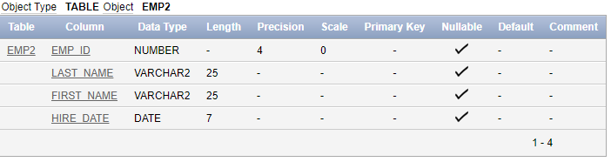

**Answer:**

Create table EMP2(ID number(7),Last_Name Varchar(25),First_Name Varchar(25),Hire_Date Date);

Describe EMP2;

**Practice Question 6**

Insert data into **EMP2** Table. Data is shown in following output

**See output below (data can be in any sequence)**

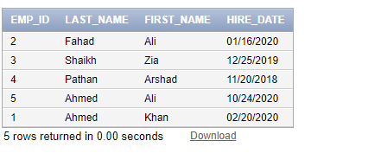

**Answer:**

1. Insert into EMP2(ID,LAST_NAME,FIRST_NAME,HIRE_DATE)

VALUES(2,'Fahad','Ali','01/16/2020');

2. Insert into EMP2(ID,LAST_NAME,FIRST_NAME,HIRE_DATE)

VALUES(2,'Shaikh','Zia','12/25/2019');

3. Insert into EMP2(ID,LAST_NAME,FIRST_NAME,HIRE_DATE)

VALUES(3,'Pathan','Arshad','11/20/2018');

4. Insert into EMP2(ID,LAST_NAME,FIRST_NAME,HIRE_DATE)

VALUES(4,'Ahmed','Ali','10/24/2020');

5. Insert into EMP2(ID,LAST_NAME,FIRST_NAME,HIRE_DATE)

VALUES(5,'Ahmed','Khan','02/20/2020');

Select *

From EMP2;

**Practice Question 7**

Try to insert a record into EMP2 Table using **SYSDATE** keyword of Oracle.

i.e insert into emp2 values(6, 'You Last Name', 'Your First name', SYSDATE)

**Answer:**

Insert into EMP2(ID,LAST_NAME,FIRST_NAME,HIRE_DATE)

VALUES(6,'Ali','Mubashir',SYSDATE);

**Practice Question 8**

Creating an **EMP3** Table from the rows returned from **EMP2** and copying data returned from query.

Try following query

**create table emp3**

**AS**

**select emp_id, last_name, first_name, hire_date from emp2**

**Correct Query:**

**Answer:**

create table EMP3

AS

select ID as Emp_id,LAST_NAME as last_name,FIRST_NAME as first_name,HIRE_DATE as hire_date

from EMP2;

select *

from EMP3;

**Practice Question 9**

Create an **EMP4** table from the following row returned from employees table

|  |  |  |  |  |  |
| --- | --- | --- | --- | --- | --- |
| **Employee_id** | **First_name** | **Last_name** | **Job_id** | **Salary** | **Hire_date** |
|  |  |  |  |  |  |

**Answer:**

Create table EMP4

AS

select Employee_id,First_name,Last_name,Job_id,Salary,Hire_date

from Employees;

select *

from Employees;

**Practice Question 10**

Create a **Students’** table with timestamp datatype of admission date attribute

|  |  |  |  |  |  |
| --- | --- | --- | --- | --- | --- |
| **Roll_no** | **First_name** | **Last_name** | **Address** | **Phone** | **Admission_date** |
| Length(7)  Number | Length(20)  Varchar | Length(20)  Varchar | Length(3)  Varchar | Length(8)  Number | Timestamp |

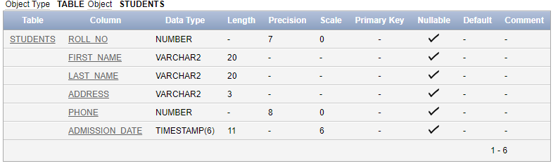

**Answer:**

Create table Students(Roll_no number(7),First_name Varchar(20),Last_name Varchar(20),Address Varchar(3),Phone number(8),Admission_date Timestamp);

Describe Students;

**Practice Question 11**

Insert data into **Students** Table. See data below (User SYSDATE to insert current date and time)

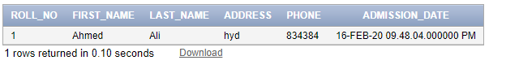

**Answer:**

Insert into Students(Roll_no,FIRST_NAME,LAST_NAME,Address,Phone,Admission_date)

VALUES(1,'Ahmed','Ali','hyd',834384,SYSDATE);

Select *

From Students;